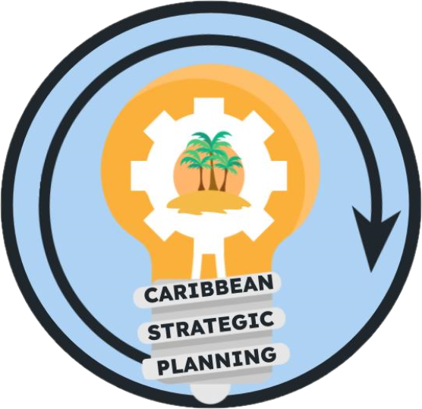Team Charter

Project: Develop life history data gap team to develop and prioritize data inventory

**Purpose**

Our purpose is to identify and inventory all known life history data collections, including historical and ongoing, in Puerto Rico and the USVI and use the inventory to identify gaps for prioritization in terms of implementation of data collections critical to stock assessment improvement.

**Goals**

Our goals are…

1. Identify priority species by island
2. Identify available life history data including what has been done in the past and what research is ongoing
   1. Classify these data as FI or FD
3. Summarize the identified life history data sources
4. Identify life history data needs by species and spatial extent
5. Provide recommendations to the stakeholders to implement data collections that fill the data gaps and inform stock assessment using the most current available data

Our ideal outcomes are to have an inventory that can be searched by species, size bin, and years that allows for identification of data needs; to have a list of specific data needs

The deliverables will be:

1. An inventory of US Caribbean Life History data sources in the form of a living database accessible for all stakeholders
2. A final report out presentation to the strategic planning members
3. A written final report that includes the data gaps and prioritization of data needs

**Team**

* *Lead*: Noemi Peña
* *Members*: Michelle Sharer-Umpierre, Stephanie Martinez, Jesús Rivera, Robert Allman, Virginia Shervette
* *Stakeholders*: CFMC, CIMAS, DNER/DRNA, DPNR, EBFM TAP, NOAA HQ, NPS, PRSG, QM/CI PSG, SEFSC, SERO, SSC, UPR, USC-A, UVI
* *KSAs*: as we progress in the working group, we will be able to identify missing data collections by species and reach out to colleagues who may know of historical or current work; Sennai Habtes may be able to speak to USVI life history work; current working group members are currently performing life history work and have knowledge of historical research

**Team Process**

* *Meeting day/time*: Wednesday/1pm-2pm (2nd meeting August 30th)
* *Meeting frequency*: Monthly
* *Decision-making procedures*: group consensus
* *Team communication*: Google Meet for meetings and communication between meetings via email

**Team Norms**

* *Values*:
  + Integrity, reproducibility, transparency, and communication of data
  + Innovation through adaptive management and continuous improvement
  + Respect and trust in data and partnerships
  + Diversity and inclusivity of data sources, data input, communities, and stakeholder ideas
  + Collaboration and cooperation in the collection and dissemination of data
* *Agreements*: The Team agrees to work in an environment of mutual respect where all Team Members will be given an opportunity and encouraged to present ideas and viewpoints. Hand raising will not be needed during google meets as long as team members do not talk over each other.

**Supporting Resources**

* *Google Drive folder*: [Working Groups](https://drive.google.com/drive/folders/1GR0WWtq_eOGT89s0n8p1imwZ1ntcnczN)
* *Project facilitation*: Rachel Banton (rachel.banton@noaa.gov)
* *Process facilitation*: Richard Maclin, Vivian Matter (vivian.matter@noaa.gov), Jenny Suter (jenny.suter@noaa.gov)

**Metrics**

Success will be measured by a document or living database that prioritizes the life history data needs